**ID Generation Strategies**

Hibernate provides various identifier generation strategies using annotations, similar to what we have seen in XML mappings. In the previous snippet, the ID generation strategy was not set, meaning it is by default employing an AUTO Strategy. When the strategy is AUTO, Hibernate relies on our database to generate primary keys. For example, if we have defined a primary key with the AUTO_INCREMENT option in MySQL, Hibernate uses that option accordingly.

We can set up different strategies depending on our requirements. All we need to do is add @GeneratedValue annotation to the id variable. This annotation accepts two attributes: strategy and generator. The *strategy* attribute indicates the type of identifier generation that we would like to use, while *generator* defines the methods to generate the identifiers.

The following code snippet uses the IDENTITY strategy for its ID generation:

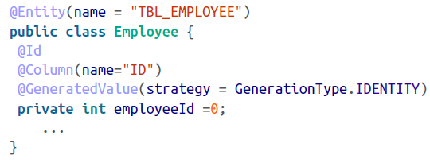

Notice that for the IDENTITY strategy, we have to provide the generator method, as this depends upon the identity function provided by the database. The *identity* function is supported by a few databases, including MySQL, Sybase, and DB2.

The strategy should be the *Generator* Type value, as described in the following

***GeneratorType.AUTO*** This is the default strategy and is portable across different databases. Hibernate chooses the appropriate ID based on the database.

***GeneratorType.IDENTITY*** This setting is based on the identity provided by some databases; it is the responsibility of the database to provide a unique identifier.

***GeneratorType.SEQUENCE*** Some databases provide a mechanism of sequenced numbers, so this setting will let Hibernate use the sequence number.

***GeneratorType.TABLE*** Sometime the primary keys have been created from a unique column in another table. In this case, use the TABLE generator.

For employing a sequence strategy, you must define both the strategy and the sequence generator:

For employing a sequence strategy, you must define both the strategy and the sequence generator:

